International Journal of Engineering & Applied Sciences (IJEAS)
Vol.XX, Issue X (XXXX) XXX-XXX
http://dx.doi.org/10.24107/ijeas.XXXXX
Int J Eng Appl Sci XX(X) (XXXX) XXX-XXX

Title of the Communication
Name Surname ^{a*}, Name Surname ^{b} and Name Surname ^{c}
^{a,b} Institution of authors 1 and 2
^{c} Institution of author 3
*E-mail address: mail@institute.edu.com

ORCID numbers of authors:
0000-0000-0000-0000*, 0000-0000-0000-0000
Received date: Keep as blank
Accepted date: Keep as blank

Abstract
The abstract must have the synthesis of the communication’s content and it should be given two lines below the author name(s) without any intends, size 10 pt in italics. The paragraph should begin with abstract and should not exceed 200 words highlighting the main points of the manuscript. Keywords should be given one line below the abstract without any intends; size 10 pt.
Keywords: Keywords should be given one line below the abstract without any intends; size 10 pt. Maximum 5 keywords should have given.
1. Introduction
The manuscripts should be written in English. Each manuscript should not exceed 15 pages including text, figures, tables and references.
2. General Instructions
The papers must be elaborated according to the indications given in this template. In order to simplify the authors work, this file contains all those indications.
The text in the papers should be presented in A4 format, with the following margins:
(i) top margin 2.5 cm; (ii) bottom margin 2.5 cm; (iii) left margin 2.5 cm and (iv) right margin 2.5 cm. The whole text is to be written with single spacing, using Times New Roman font, Size 12.
3. Title, authors, institution and abstract
The first page includes the title of the paper, the names of the authors and their institutions, and an abstract. The following vertical spacing must be used:
1. between the line and the title: 12 pt;
2. between the title and the names of authors: 36 pt;
3. between the names of authors and their institutions: 12 pt;
4. between the institutions and the abstract: 24 pt;
3.1. Title of the paper
The title of the manuscript should be centered, in capital for first letters. Times New Roman font, size 12, in bold. In case there is no more than one line of text, single spacing must be used.
3.2. Names of authors and institutions
The names of the authors should appear under the title of the paper, with a vertical spacing of 36 pt, centered in the same line of text in italics and bold. The names should include the first name, the initials of the middle and the last names (ex.: Nakagawa, A. and Zarrugh, M.Y.). The institutions of the authors should appear under the names, with a vertical spacing of 10 pt, centered, size 10 letters in italics.
3.3. Abstract
The abstract must have the synthesis of the communication’s contents and it mustn’t exceed 200 words. It should appear under the email address of corresponding author, with a vertical spacing of 24 pt. Two blank lines should be kept before the “Introduction”. The abstract should be written in size 10 letters in italics, and the text should be justified. The word “Abstract”, also written in size 10, bold, appears at the beginning of the first line.
4. Sections
4.1. Main Sections
The titles of the main sections should be written in small letters, the first letter being capital, size 12, bold and aligned to the left. Before a main title, two blank lines should appear, while after the main title one blank line must be kept.
4.2. Secondary Sections
The titles of the secondary sections should be written in small letters, the first letter being capital, size 12, bold and aligned to the left. Before a main title, two blank lines should appear, while after the main title one blank line must be kept.
4.2.1 Tertiary sections
The titles of the tertiary sections should be written in small letters, the first letter being capital, size 12, normal and aligned to the left. Only the number of the section appears in bold. Before a tertiary title, one blank line must be kept.
4.2.2 Footnotes
Do not include footnotes in the text of the manuscript.
5. Text
The text of the manuscript is written with single spacing, justified, with Times New Roman font, size 12. No blank lines are to be left between paragraphs.
The manuscript should include an introduction and the final conclusions.

6. Equations, figures and tables
6.1. Equations
The equations must be centered in the text and must be numbered. The numbering should appear in the same line of the equation, with a number between brackets and aligned to the right. The equations are written in Times New Roman font, size 12. A blank line is to be left before or after the equations.
Every time there is the necessity to mention an equation in the text, the following notation must appear: Eq. (x). For example “(…) The condition expressed in Eq. (2) is only verified (…)”.

(1)
6.2. Figures and tables
Tables and figures should be prepared in related computer software(s) and others should be drawn according to technical drawing rules. All tables and figures must be incorporated into the main text. The tables and the figures should not appear at the end of the paper.
6.2.1. Tables
The tables must be subtitled. The subtitles should appear above the tables, centered in text, in Times New Roman, size 11. One blank line must be left between the text and the table subtitle and another blank line must appear after the table. No blank lines are to appear between the table and its subtitle. All tables must be referred to in text as “Table x”. Example:

Table 1. Subtitle (mm)
$$l_{7}$$ | $$l_{6}$$ | $$l_{5}$$ | $$l_{4}$$ | $$l_{3}$$ | $$l_{2}$$ | $$l_{1}$$
50 | 35 | 40 | 55 | 60 | 90 | 35 | $$l_{i\text{max}}$$
25 | 10 | 15 | 20 | 30 | 50 | 5 | $$l_{i\text{min}}$$
6.2.2. Figures
All figures must be subtitled. The subtitles of the figures appear under the corresponding figures, centered in text, in Times New Roman font, size 11. One blank line should be left before the figure, and another must be left after the subtitle, before the text. Between the figure and the subtitle there are no blank lines. All figures must be referred to in text as “Fig. x” .Examples:

 | 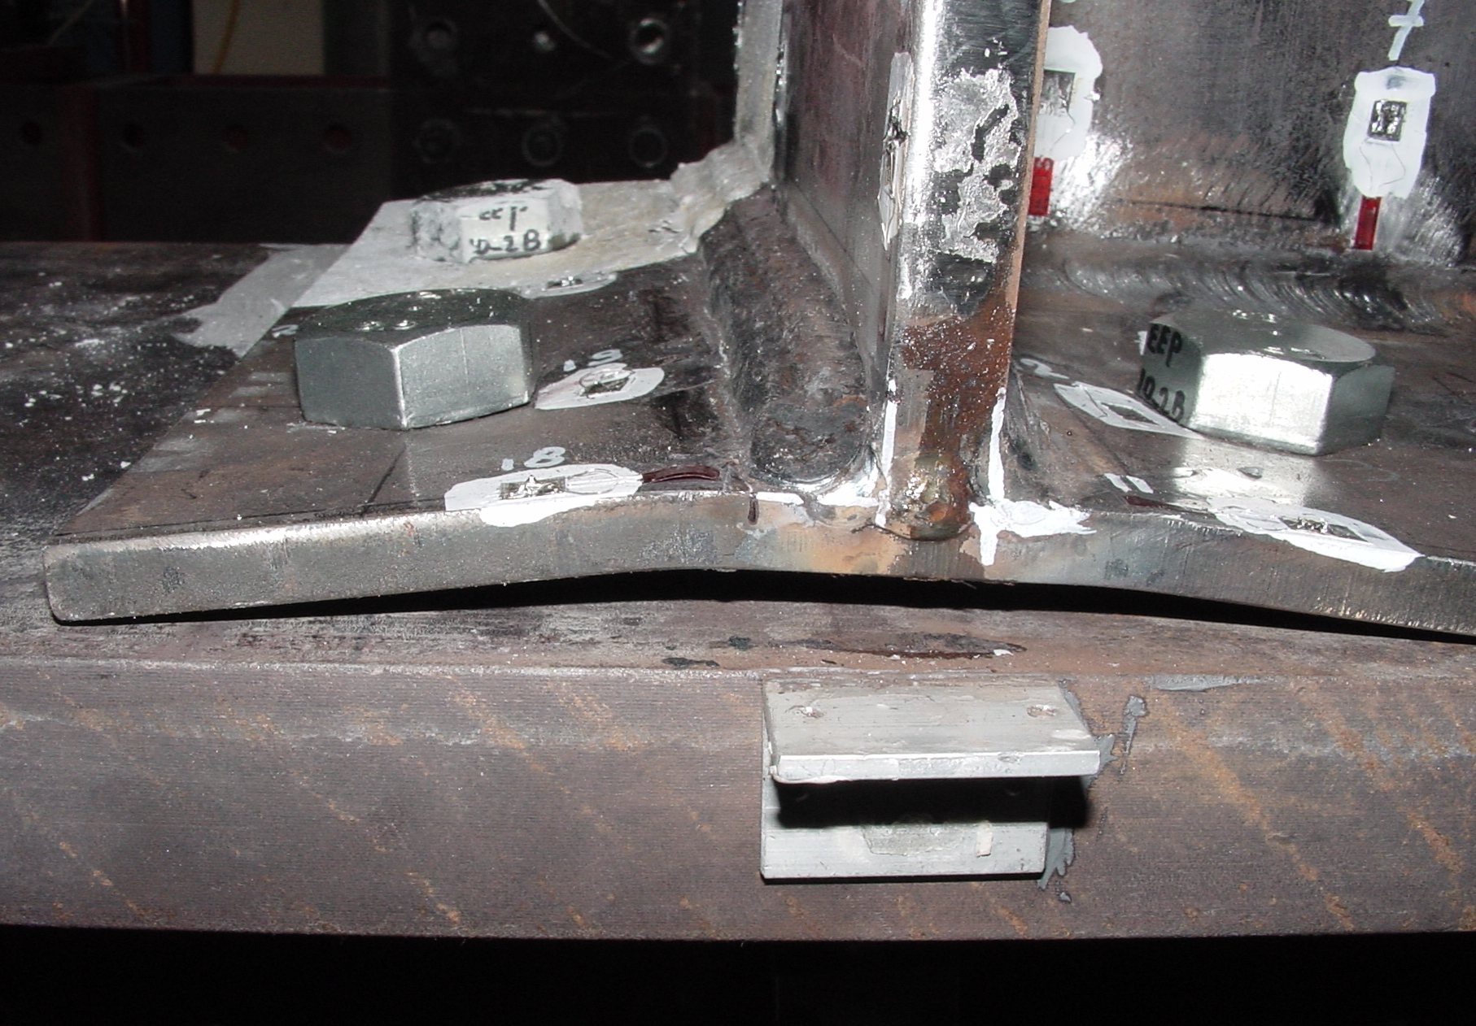
a) Example 1 | b) Example 2
Fig.1. Subtitle

Fig.2. Subtitle (example for a graphic)

7. Conclusions
The paper must have a section for final conclusions. The authors should respect the formatting rules presented in this document. We suggest that you use this template, which is already formatted according to the mentioned rules.
Acknowledgments
The authors can include an acknowledgment section, after the conclusions. These sections should not be numbered.
Notations
The authors can include an acknowledgment section, after the conclusions. These sections should not be numbered. All notations must be mentioned in the text. The variables should be written in italics, except for Greek capitals, which should be written in normal style. If necessary, a list of notations can be created (section not numbered), before the “References” section. In that case, the following format should be used:

b Width
E Young’s Module
$δ$ Strength
$Δ$ Axial stretching
References
The references should appear at the end of the paper, under the title “References”. This section is not numbered. Along the text, the references are marked with a number between square parentheses. As example: “(...) The numeric model that is described in literature [1,2] and covers the analysis (...)”.
The quotes are mentioned by their order of appearance in text, in Times New Roman font, size 12. No blank lines are to be left between references. Some examples for the format of the references can be found below:

Journals:

[1] Wei, G.W., Zhao, Y.B., Xiang, Y., Discrete singular convolution and its application to the analysis of plates with internal supports, I theory and algorithm. International Journal for Numerical Methods in Engineering, 55, 913-946, 2002.

Conferences:

[2] Dicleli, M. and Bruneau M., Non-Linear Seismic Response of Single Span Simply Supported Slab-on-Girder Steel Highway Bridges with Damaged Bearings, Seventh Canadian Conference on Earthquake Engineering, Montreal, Canada, 1995.

Books:

[3] Cengel, Y.A., Heat Transfer: A Practical Approach, McGrraw-Hill Companies; 2nd edition, 2002.

Patent:

[4] Cookson, A.H., Particle Trap for Compressed Gas Insulated Transmission Systems, 1985, US Patent 4554399.

