**Akdeniz Iletişim Main Title**

Article Type (Çalışma Türü): Research / Araştırma

Submitted (Başvuru Tarihi):02.02.2023

Accepted (Kabul Tarihi): 31.03.2023

Cite as (Atıf): Surname, N. & Surname, N. (YEAR)

Manuscript Title. Akdeniz İletişim, (40), … DOI Link.

**Akdeniz Iletişim Main Title**

**Main Title Akdeniz Iletişim**

*Akdeniz Iletişim Secondary Title*

**Author Name SURNAME[1]**

**Author Name SURNAME[2],**

**Author Name SURNAME[3]**

**Abstract**

Copy and paste the Abstract text you have prepared into this field. The Abstract should be a minimum of 150 and a maximum of 250 words. Abstract text font: Calibri (Body), 9 pt; Line spacing: Single; Bold Line spacing: Single; Spacing before: 0 pt; Spacing after: 6 pt (Must be positioned without paragraph indentation); justified. Articles should include both Turkish and English abstracts, consisting of maximum 250 words. The preparation of the articles to be submitted to AKDENIZ ILETIŞIM in line with this template will accelerate the editing, evaluation and publication stages. In abstracts, care should be taken to include information on the research problem, purpose, method, main findings and results in accordance with APA JARS standards. In-text citations and abbreviations should be avoided in abstracts. Underlined, bold or italic fonts should not be applied in abstracts. Abstracts should be followed by keywords (min. 3, max. 5 keywords) that will best express the article. Keywords should be formatted as follows: Keyword font type: Calibri (Body), 9 pt; Line spacing: Single; Spacing before: 0 pt; Spacing after: 6 pt.

**Keywords:** *Keyword 1, Keyword 2, Keyword 3, Keyword 4, Keyword 5*

Öz

Hazırlamış olduğunuz Öz metnini kopyalayıp bu alana yapıştırınız. Öz kısmı en az 150, en fazla 250 kelime olmalıdır. Öz ve Abstract metni Yazı tipi: Calibri (Body) 9 punto; Satır aralığı: Tek; Kalın satır aralığı: Tek; Aralık önce: 0 nk; Aralık sonra: 6 nk (Paragraf girintisi olmayacak şekilde konumlandırılmalı) iki yana yaslı olarak yazılmalıdır. Makalenin başında, en fazla 250 kelimeden oluşan metnin hazırlandığı Türkçe ve İngilizce özler yer almalıdır. AKDENIZ ILETIŞIM’a gönderilmek üzere hazırlanan makalelerin bu şablona bağlı olarak hazırlanması makalenin düzenlenme, değerlendirilme ve yayımlanma aşamalarını hızlandıracaktır. Özlerde; APA JARS standartlarına uygun olacak şekilde araştırma problemi, amacı, yöntemi, temel bulguları ve sonuçlarına ilişkin bilgilerin yer almasına özen gösterilmelidir. Öz metni içerisinde atıfta bulunulmamalı ve kısaltma kullanılmamalıdır. Öz metinlerinde altı çizili, kalın veya italik yazı tipinden kaçınılmalıdır. Öz metninin sonunda en az 3 en fazla 5 kelimeden oluşan, konuyu en iyi şekilde ifade edecek anahtar kelimeler (Keywords) yer almalıdır. Anahtar kelimeler için Yazı tipi: Calibri (Body), 9 punto; İtalik; Satır aralığı: Tek; Aralık Önce: 0 nk; Aralık Sonra: 6 nk olarak ayarlama yapılmalıdır.

**Anahtar Kelimeler:** *Anahtar Kelime 1, Anahtar Kelime 2, Anahtar Kelime 3, Anahtar Kelime 4, Anahtar Kelime 5.*

**Introduction**

All author candidates who submit a manuscript to AKDENIZ ILETIŞIM are deemed to have committed to preparing their manuscript in accordance with the rules specified here. Manuscripts that do not comply with these rules will be rejected by the editorial board at the preliminary evaluation stage without being sent to the reviewers for further peer-review processes.

Guidelines and rules are meticulously applied to act in accordance with the rules of the indexes to which AKDENIZ ILETIŞIM is subject, and to be accepted by higher level journal indexes by publishing qualified studies. Thus, studies that do not comply with these rules are rejected at the preliminary evaluation stage. For minor deficiencies in terms of Author Guidelines, revisions are requested from the authors, but no concessions are made in these revision requests. For this reason, it is of great importance for author candidates who are considering submitting their manuscript to AKDENIZ ILETIŞIM to take into account the rules and recommendations in this section.

In addition, we would like to inform that it is the authors' own responsibility to follow the processes. All responsibility for the delays caused by the author belongs to the author.

Manuscripts submitted to AKDENIZ ILETIŞIM must be original and must not have been published elsewhere and sent for publication. The preliminary, peer-review and/or publication processes of the manuscripts that are found to be published in other journals or publications are terminated.

Manuscripts should be prepared by using the MS Office Word program (.doc, .docx). No other formats are accepted.

Manuscripts should employ in-text references for citations instead of footnotes. If footnotes are needed, footnotes should be written in 8 pt and single line spacing.

Due to the indexation rules that AKDENIZ ILETIŞIM is subject to, the same author cannot publish more than one article in a year. In addition, each author is required to submit only one (1) manuscript in one issue for consideration. An author (whether first, second, third, etc.) may submit only one (1) manuscript per issue. Otherwise, all manuscripts submitted by an author will be rejected at the preliminary evaluation stage.

The main titles of the manuscript (including the titles of Introduction, Conclusion, References) should be written in lowercase, Calibri (Body), 12 point, bold and centered, with the first letters capitalized. Except for the main title, (Introduction, Conclusion, and References), all titles should be numbered and these numbered titles should be left-justified in the text. The maximum length for main title is 12 words. Headings and subheadings should be short and clear. Please consider the Manuscript Template.

Pages should be arranged with 1.27 cm margins on the right, left, top and bottom. Paragraphs in the manuscript should be indented. Paragraph spacing should be 0 pt first and then 6 pt. Page numbers should not be added. The titles of figures, graphics and pictures are at the bottom in 10 pt, in the middle and in bold. Table headings should be in 10 font size, left aligned and numbered in bold at the top.

It will be appropriate for manuscripts to comply with the following order in the studies: English Title, Abstract, Keywords, Turkish Title, Abstract in Turkish (Öz), Keywords in Turkish, Introduction, Methodology, Results, Discussion, Conclusion and References. APA Journal Article Reporting Standards (JARS) must be applied.

All authors who have contributed to the submitted manuscript should be stated as an author of the manuscript. If this is not notified by the corresponding author at the beginning, no corrections regarding author contributions will be processed even if the authors request any correction from AKDENIZ ILETIŞIM later. AKDENIZ ILETIŞIM has no legal responsibility in this sense. Authors who submit articles to AKDENIZ ILETIŞIM are deemed to have accepted the legal issues.

No author information should be included in the manuscript files sent for evaluation.

**1. Methodology**

It is AKDENIZ ILETIŞIM’s priority criteria that;

1. all manuscripts to be submitted are written in accordance with APA’s journal article reporting standards (available at https://apastyle.apa.org/jars)

2. their references are arranged by using Mendeley (https://www.mendeley.com/) or Endnote (https://endnote.com/) reference managers.

3. the number of words used in the titles is at most 12, the number of words used in the abstract is between 150-250, and the number of words in the manuscript is between 5000-8500 (including the abstract, tables and footnotes, excluding the References and Extended Abstract).

4. the manuscripts are scanned for plagiarism on Turnitin or iThenticate, and their originality reports are uploaded to the Manuscript Submission System.

**1.1. Tables, Figures, and Appendices**

Table, figure, and images should be appropriately numbered and titled. Captions of figures, graphics and pictures are in Calibri (Body) font and 10 points, at the bottom and at the center; Table headings should be numbered in Calibri (Body) font and 10 points, at the top and in the center.

In accordance with the copyright law, the necessary permissions for the tables, images, figures, etc. used in the manuscript should be obtained by the authors, and the permission letter should be uploaded to the Manuscript Submission System.

**Tablo 1.** Presentation of Sample Table

|  |  |  |
| --- | --- | --- |
| Column 1 | Column 2 | Column 3 |
| Calibri (Body) 10 pt | Calibri (Body) 10 pt | Calibri (Body)  10 pt |

**Source:** Explanation of the Table Source if any

Titles of figures, graphics and pictures should be placed in Calibri (Body) font and numbered at the bottom and in the center with 10 points.

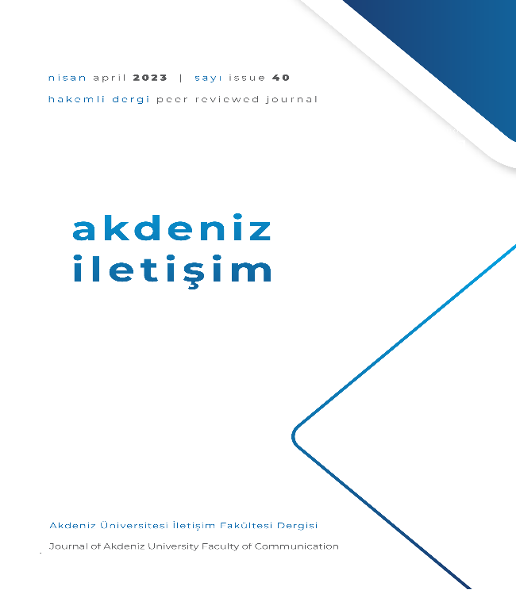

**Figure 1.** Sample Presentation of Figures, Images, and Graphics

If the work has appendices, they should be added after the References.

**2. Results / Findings**

The files to be uploaded separately from the Manuscript Template are stated below:

* Turnitin / iThenticate Originality Report,
* Cover Letter (in which authors’ information regarding their names, ORCID numbers, e-mail addresses, phone numbers and their short bio are provided) (should be filled and signed by all authors),
* Copyright Transfer Form (should be filled and signed by corresponding authors),
* Letter of Approval by Institutional Review Boards (where required).

**3. Discussion**

No author information should be included in the manuscript files sent for evaluation.

If the manuscripts have been previously presented in a meeting / symposium, the date and place of the meeting/symposium should be stated in the Cover Letter.

Manuscripts produced only from doctoral dissertations are accepted for evaluation, those produced from master's thesis are not evaluated.

If the manuscript was previously submitted as a doctoral dissertation and is produced from that dissertation, the title of the doctoral thesis should be stated and the information regarding the institute/institution, supervisor, etc. must be reported in the Cover Letter. The editorial board has the right to remove an article that was detected to have been produced from a doctoral thesis, even after it has been published, even though it was not notified by the author.

If the manuscript produced from the doctoral dissertation is submitted to AKDENIZ ILETIŞIM as a manuscript produced by a single name, the petition of the doctoral dissertation supervisor notifying that he has waived all his rights (it is mandatory to have the doctoral dissertation supervisor’s wet signature) must be uploaded to the system. Thesis abstracts with a single name will be rejected at the preliminary evaluation stage if they do not upload this petition to the system.

**Conclusion**

If the manuscript has been supported by a funding agency, the information regarding the funder, project number, etc. must be reported in the Cover Letter.

APA 7 citation rules (https://apastyle.apa.org/style-grammar-guidelines) should be considered when making in-text references to the sources used in the manuscripts and preparing the references at the end of the manuscript. The works in the references should be listed alphabetically. The works in the references should be included in the text, and the works cited in the text should be included in the References.

All legal, academic, ethical, etc. responsibility belongs to the author(s). Manuscripts should not contain plagiarism, and originality report obtained from Turnitin or iThenticate should be uploaded to the Manuscript Submission System together with the study. For manuscripts to be evaluated, the Turnitin/ iThenticate originality report must be 15% or less (with less than 9 words, including citations, excluding references). The rate of quoting from the same study should be at most 3%. Manuscripts with a similarity rate above or those without a Turnitin/iThenticate report will be desk-rejected.

All manuscripts prepared in Turkish or English must have been grammarly proofread by a native speaker.

**Declarations**

* *Approval of Institutional Review Board (IRB):* If human factor is involved in research articles, then the Letter of Approval by Institutional Review Boards should be uploaded to the system. Manuscripts that do not require such letter are required to upload a wet-signed petition to the system for notifying this situation. Manuscripts that have received IRB approval should add information about the approval decision date and number in the relevant field both in the Declarations section and under the Methodology heading.

* *Authors’ Contribution Rate:* In manuscripts with more than one author, the contribution rate of the authors to the study should be presented as a percentage (%). In single-author manuscripts, the phrase "Not applicable" should be added to the "Author Contribution Rate" information.

*\* Conflict of Interest:* It may arise when the author(s) of the study or the institution to which the author(s) are affiliated or their financial supporter has any direct or indirect financial, commercial, legal or professional relationship/interest with other institutions or the employees of these other institutions that may affect the research. The corresponding author has to declare whether there is a conflict of interest in the study, taking into account all these issues.

* *Funding:* If the study was supported by any academic financial support institution (TÜBİTAK, BAP, European Union, United Nations, etc.), the information of the financial support provider, project number, etc. must be reported.

* *Acknowledgements:* If the study was produced from a thesis, presented at a congress/symposium/conference, or if any other author statement is needed for similar subjects, it should be presented in full in this section.

**References**

Please use Mendeley, Zotero or Endnote for reference management in your manuscript.

Akdeniz Iletişim requires manuscripts to comply with the APA Style (7th Edition).

1. Author information
2. Author information
3. Author information