Article Title (The first letter of each word is capitalized)
 | Author Information
Name SURNAME
Title, Institution/University, City/Country, e-mail
ORCID ID: https://orcid.org/
 | Article Info
Article Type |  | :
Received |  | :
Accepted |  | :
Published |  | :
(Leave this section blank. It will be filled by the journal after the relevant study is accepted.)
 | Cite
Surname, N., & Surname, N. (Year). English title of the article. EDUCATIONE, X(X), XX-XX.

(Leave this section blank. It will be filled by the journal after the relevant study is accepted.)

Abstract
It should cover the purpose of the study, its method, significant features and results briefly and clearly. It should be approximately 150-250 words. It should cover the purpose of the study, its method, significant features and results briefly and clearly. It should be approximately 150-250 words. It should cover the purpose of the study, its method, significant features and results briefly and clearly. It should be approximately 150-250 words. It should cover the purpose of the study, its method, significant features and results briefly and clearly. It should be approximately 150-250 words. It should cover the purpose of the study, its method, significant features and results briefly and clearly. It should be approximately 150-250 words. It should cover the purpose of the study, its method, significant features and results briefly and clearly. It should be approximately 150-250 words. It should cover the purpose of the study, its method, significant features and results briefly and clearly. It should be approximately 150-250 words. It should cover the purpose of the study, its method, significant features and results briefly and clearly. It should be approximately 150-250 words. It should cover the purpose of the study, its method, significant features and results briefly and clearly.
Keywords: Keywords1, Keywords2, Keywords3

INTRODUCTION
Palatino linotype font type, 12 font size, justified, 1,15 line spacing, 6 nk space before and after the paragraphs, indents should not used in text. Palatino linotype font type, 12 font size, justified, 1,15 line spacing, 6 nk space before and after the paragraphs, indents should not used in text. Palatino linotype font type, 12 font size, justified, 1,15 line spacing, 6 nk space before and after the paragraphs, indents should not used in text.
Palatino linotype font type, 12 font size, justified, 1,15 line spacing, 6 nk space before and after the paragraphs, indents should not used in text. Palatino linotype font type, 12 font size, justified, 1,15 line spacing, 6 nk space before and after the paragraphs, indents should not used in text. Palatino linotype font type, 12 font size, justified, 1,15 line spacing, 6 nk space before and after the paragraphs, indents should not used in text.
(Birinci Düzey Alt Başlık) Purpose of the research
Palatino linotype font type, 12 font size, justified, 1,15 line spacing, 6 nk space before and after the paragraphs, indents should not used in text.
(İkinci düzey alt başlık) Alt amaçlar
Palatino linotype font type, 12 font size, justified, 1,15 line spacing, 6 nk space before and after the paragraphs, indents should not used in text.
METHODOLOGY
Palatino linotype font type, 12 font size, justified, 1,15 line spacing, 6 nk space before and after the paragraphs, indents should not used in text.
Research Design
Palatino linotype font type, 12 font size, justified, 1,15 line spacing, 6 nk space before and after the paragraphs, indents should not used in text.
Study Group
Palatino linotype font type, 12 font size, justified, 1,15 line spacing, 6 nk space before and after the paragraphs, indents should not used in text.
Data Collection Tools
Palatino linotype font type, 12 font size, justified, 1,15 line spacing, 6 nk space before and after the paragraphs, indents should not used in text.
Data Analysis
Palatino linotype font type, 12 font size, justified, 1,15 line spacing, 6 nk space before and after the paragraphs, indents should not used in text.
FINDINGS
Palatino linotype font type, 12 font size, justified, 1,15 line spacing, 6 nk space before and after the paragraphs, indents should not used in text.
Table 1. The title of table should be written italic
Test | Grade | K-S | Skewness | Z Score | Kurtosis | Decision
Native Language Awareness Scale | 2 | 0,200 | -0,304 | -0,98 | -0,665 | Skewed Distribution
 | 3 | 0,002 | -0,970 | -30,17 | 0,960
 | 4 | 0,014 | -0,460 | -10,50 | -0,765
Table title: Palatino linotype font type, 11 font size, justified, 1,15 line spacing, 6 nk space before and after the paragraphs. The font size of the text in the table should be 10 and it can reduced up to 8 if needed.
Palatino linotype font type, 12 font size, justified, 1,15 line spacing, 6 nk space before and after the paragraphs, indents should not used in text.
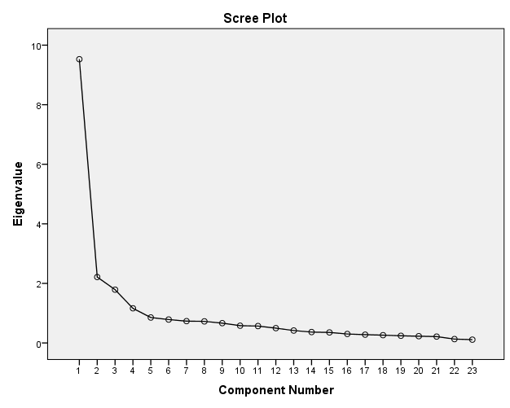
Figure 1. The title of figure should be written italic
Figure titles: Palatino linotype font type, 11 font size, centered
Palatino linotype font type, 12 font size, justified, 1,15 line spacing, 6 nk space before and after the paragraphs, indents should not used in text. Palatino linotype font type, 12 font size, justified, 1,15 line spacing, 6 nk space before and after the paragraphs, indents should not used in text.
CONCLUSION, DISCUSSION AND SUGGESTIONS
Palatino linotype font type, 12 font size, justified, 1,15 line spacing, 6 nk space before and after the paragraphs, indents should not used in text. Palatino linotype font type, 12 font size, justified, 1,15 line spacing, 6 nk space before and after the paragraphs, indents should not used in text. Palatino linotype font type, 12 font size, justified, 1,15 line spacing, 6 nk space before and after the paragraphs, indents should not used in text.
Palatino linotype font type, 12 font size, justified, 1,15 line spacing, 6 nk space before and after the paragraphs, indents should not used in text. Palatino linotype font type, 12 font size, justified, 1,15 line spacing, 6 nk space before and after the paragraphs, indents should not used in text. Palatino linotype font type, 12 font size, justified, 1,15 line spacing, 6 nk space before and after the paragraphs, indents should not used in text.
Palatino linotype font type, 12 font size, justified, 1,15 line spacing, 6 nk space before and after the paragraphs, indents should not used in text. Palatino linotype font type, 12 font size, justified, 1,15 line spacing, 6 nk space before and after the paragraphs, indents should not used in text. Palatino linotype font type, 12 font size, justified, 1,15 line spacing, 6 nk space before and after the paragraphs, indents should not used in text.
Contribution Rate of Authors (If there is more than one author)
The contribution rate of each author to the study should be stated.
Statement of Support and Acknowledgment (If any)
If there are institutions and/or people who supported the research, they should be stated under this heading and acknowledged.
Conflict of Interest
It should be stated whether there is any conflict between the authors.
REFERENCES
Palatino linotype font type, 10 font size, justified, 1,15 line spacing, 6 nk space before and after the paragraphs, indents should not used in text.
The bibliography, reference and citation control of accepted articles should be arranged according to the procedures and principles in the 7th edition of the APA Citation Rules.

